Cognitive Processing

|  |  |  |  |  |  |
| --- | --- | --- | --- | --- | --- |
|  | logLik | df | ΔlogLik | Δdf | Critical |
| Null Model | -4169.901 | 2257 |  |  |  |
| Null Nested Model | -3791.019 | 1703 | 378.882 | 554 |  |
| Null Nested Model 2 | -3674.999 | 1698 | 116.02 | 5 | 11.07 |
| Nested Model | -3578.802 | 1681 | 96.188 | 17 | 27.59 |

|  |  |  |  |  |  |  |
| --- | --- | --- | --- | --- | --- | --- |
|  | Estimate | SE | *t* | *p* | 95% CI | |
| Intercept | 1.405 | .950 | 1.479 | .139 | -.875 | 3.694 |
| Party Affiliation | .201 | .102 | 1.971 | .049 | .001 | .401 |
| Afghanistan v. Iraq | -.721 | .142 | -5.079 | <.001 | -1.000 | -.443 |
| Iran v. Iraq | -.715 | .116 | -6.173 | <.001 | -.942 | -.488 |
| North Korea v. Iraq | -.524 | .141 | -3.721 | <.001 | -.799 | -.248 |
| Russia v. Iraq | -.599 | .155 | -3.874 | <.001 | -.902 | -.296 |
| Syria v. Iraq | -.497 | .166 | -2.988 | .003 | -.823 | -.170 |
| Kosovo v. Iraq | -.459 | .183 | -2.514 | .012 | -.817 | -.101 |
| Sudan v. Iraq | -.956 | .139 | -6.885 | <.001 | -1.228 | -.683 |
| Libya v. Iraq | -.396 | .141 | -2.815 | .005 | -.672 | -.120 |
| Party * Afghanistan | .176 | .188 | .938 | .348 | -.193 | .545 |
| Party * Iran | .040 | .158 | .255 | .799 | -.270 | .350 |
| Party * North Korea | -.241 | .207 | -1.167 | .243 | -.646 | .164 |
| Party * Russia | -.177 | .216 | -.822 | .411 | -.600 | .246 |
| Party * Syria | -.214 | .224 | -.953 | .341 | -.653 | .226 |
| Party * Kosovo | .187 | .266 | .704 | .481 | -.335 | .710 |
| Party * Sudan | -.281 | .175 | -1.607 | .108 | -.624 | .062 |
| Party * Libya | -.232 | .199 | -1.166 | .243 | -.622 | .158 |

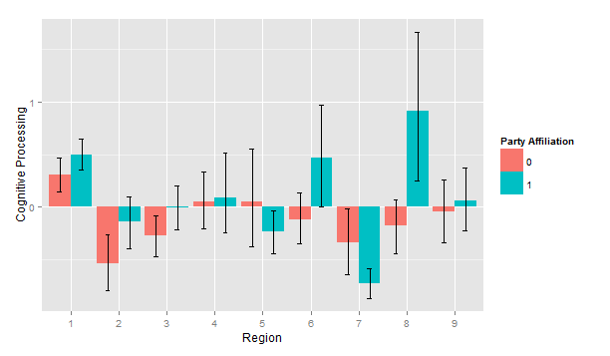

Categorical Thinking

|  |  |  |  |  |  |
| --- | --- | --- | --- | --- | --- |
|  | logLik | df | ΔlogLik | Δdf | Critical |
| Null Model | -5369.26 | 2257 |  |  |  |
| Null Nested Model | -5069.57 | 1703 | 299.69 | 554 |  |
| Null Nested Model 2 | -4800.77 | 1698 | 268.80 | 5 | 11.07 |
| Nested Model | -4738.86 | 1681 | 61.91 | 17 | 27.59 |

|  |  |  |  |  |  |  |
| --- | --- | --- | --- | --- | --- | --- |
|  | Estimate | SE | *t* | *p* | 95% CI | |
| Intercept | -1.987 | 1.095 | -1.814 | .070 | -4.649 | .624 |
| Party Affiliation | .468 | .194 | 2.418 | .016 | .088 | .848 |
| Afghanistan v. Iraq | -.419 | .235 | -1.784 | .074 | -.881 | .043 |
| Iran v. Iraq | .823 | .197 | 4.169 | <.001 | .436 | 1.210 |
| North Korea v. Iraq | .495 | .231 | 2.140 | .032 | .041 | .950 |
| Russia v. Iraq | 1.266 | .255 | 4.972 | <.001 | .767 | 1.766 |
| Syria v. Iraq | .045 | .280 | .163 | .871 | -.503 | .594 |
| Kosovo v. Iraq | .387 | .309 | 1.254 | .210 | -.219 | .993 |
| Sudan v. Iraq | .863 | .233 | 3.704 | <.001 | .406 | 1.321 |
| Libya v. Iraq | -.049 | .239 | -.204 | .838 | -.517 | .419 |
| Party * Afghanistan | -.279 | .310 | -.899 | .369 | -.888 | .330 |
| Party * Iran | -.283 | .268 | -1.056 | .291 | -.808 | .243 |
| Party * North Korea | .172 | .339 | .506 | .613 | -.494 | .837 |
| Party * Russia | -.131 | .357 | -.367 | .714 | -.831 | .569 |
| Party * Syria | .245 | .372 | .658 | .510 | -.485 | .974 |
| Party * Kosovo | -.204 | .442 | .461 | .645 | -1.072 | .664 |
| Party * Sudan | -.093 | .294 | -.317 | .752 | -.670 | .484 |
| Party * Libya | -.297 | .336 | -.884 | .377 | -.955 | .362 |

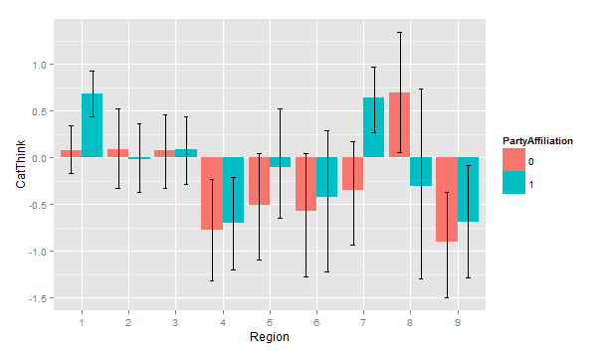

Complex Thinking

|  |  |  |  |  |  |
| --- | --- | --- | --- | --- | --- |
|  | logLik | df | ΔlogLik | Δdf | Critical |
| Null Model | -6648.21 | 2257 |  |  |  |
| Null Nested Model | -5687.36 | 1703 | 960.85 | 554 |  |
| Null Nested Model 2 | -5264.46 | 1698 | 422.90 | 5 | 11.07 |
| Nested Model | -5149.99 | 1681 | 114.47 | 17 | 27.59 |

|  |  |  |  |  |  |  |
| --- | --- | --- | --- | --- | --- | --- |
|  | Estimate | SE | *t* | *p* | 95% CI | |
| Intercept | 5.092 | 4.151 | 1.226 | .220 |  |  |
| Party Affiliation | .567 | .207 | 2.738 | .006 |  |  |
| Afghanistan v. Iraq | -1.585 | .284 | -5.577 | <.001 |  |  |
| Iran v. Iraq | -1.376 | .233 | -5.906 | <.001 |  |  |
| North Korea v. Iraq | -1.283 | .283 | -4.554 | <.001 |  |  |
| Russia v. Iraq | -1.523 | .310 | -4.917 | <.001 |  |  |
| Syria v. Iraq | -.656 | .333 | -.969 | .049 |  |  |
| Kosovo v. Iraq | -.439 | .367 | -1.196 | .232 |  |  |
| Sudan v. Iraq | -1.738 | .279 | -6.231 | <.001 |  |  |
| Libya v. Iraq | -.077 | .282 | -.272 | .786 |  |  |
| Party * Afghanistan | -.142 | .376 | -.377 | .706 |  |  |
| Party * Iran | -.154 | .318 | -.485 | .628 |  |  |
| Party * North Korea | -.451 | .414 | -1.091 | .275 |  |  |
| Party * Russia | -.277 | .432 | -.640 | .522 |  |  |
| Party * Syria | -.814 | .449 | -1.814 | .070 |  |  |
| Party * Kosovo | -1.485 | .534 | -2.784 | .005 |  |  |
| Party * Sudan | -.887 | .352 | -2.523 | .012 |  |  |
| Party * Libya | -.894 | .399 | -2.240 | .025 |  |  |

Post Hoc Tests: Complex Thinking

|  |  |  |  |  |  |  |
| --- | --- | --- | --- | --- | --- | --- |
| Kosovo | Estimate | SE | *t* | *p* | 95% CI | |
| Republican | .096 | .367 | 1.02 | .794 | -.625 | .817 |
| Democrat | -.714 | .401 | -1.78 | .075 | -1.501 | .072 |

|  |  |  |  |  |  |  |
| --- | --- | --- | --- | --- | --- | --- |
| Sudan | Estimate | SE | *t* | *p* | 95% CI | |
| Republican | .078 | .248 | -3.16 | .002 | -1.271 | -.293 |
| Democrat | -1.533 | .197 | -7.77 | <.001 | -1.920 | -1.146 |

|  |  |  |  |  |  |  |
| --- | --- | --- | --- | --- | --- | --- |
| Libya | Estimate | SE | *t* | *p* | 95% CI | |
| Republican | .943 | .253 | 3.72 | <.001 | .444 | 1.441 |
| Democrat | .410 | .281 | 1.46 | .144 | -.142 | .962 |

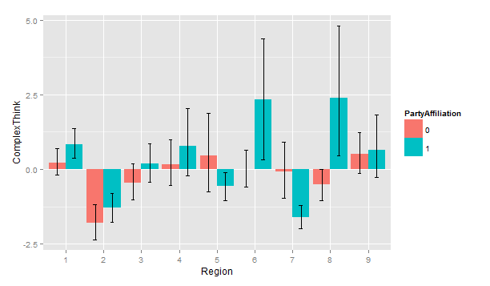

Psychological Distancing

|  |  |  |  |  |  |
| --- | --- | --- | --- | --- | --- |
|  | logLik | df | ΔlogLik | Δdf | Critical |
| Null Model | -5847.90 | 2257 |  |  |  |
| Null Nested Model | -5683.16 | 1703 | 164.74 | 554 |  |
| Null Nested Model 2 | -5335.24 | 1698 | 347.92 | 5 | 11.07 |
| Nested Model | -5288.52 | 1681 | 46.72 | 17 | 27.59 |

|  |  |  |  |  |  |  |
| --- | --- | --- | --- | --- | --- | --- |
|  | Estimate | SE | *t* | *p* | 95% CI | |
| Intercept |  |  |  |  |  |  |
| Party Affiliation |  |  |  |  |  |  |
| Afghanistan v. Iraq |  |  |  |  |  |  |
| Iran v. Iraq |  |  |  |  |  |  |
| North Korea v. Iraq |  |  |  |  |  |  |
| Russia v. Iraq |  |  |  |  |  |  |
| Syria v. Iraq |  |  |  |  |  |  |
| Kosovo v. Iraq |  |  |  |  |  |  |
| Sudan v. Iraq |  |  |  |  |  |  |
| Libya v. Iraq |  |  |  |  |  |  |
| Party * Afghanistan |  |  |  |  |  |  |
| Party * Iran |  |  |  |  |  |  |
| Party * North Korea |  |  |  |  |  |  |
| Party * Russia |  |  |  |  |  |  |
| Party * Syria |  |  |  |  |  |  |
| Party * Kosovo |  |  |  |  |  |  |
| Party * Sudan |  |  |  |  |  |  |
| Party * Libya |  |  |  |  |  |  |

